**CBA: Practice Problem Set 2**

**Topics: Sampling Distributions and Central Limit Theorem**

1. Examine the following normal Quantile plots carefully. Which of these plots indicates that the data …
2. Are nearly normal?
3. Have a bimodal distribution? (One way to recognize a bimodal shape is a “gap” in the spacing of adjacent data values.)
4. Are skewed (i.e. not symmetric) ?
5. Have outliers on both sides of the center?



**Answer:**

1. Are nearly normal?

Plot A is normally distributed with data points evenly distrusted on both sides of the centre line.

1. Have a bimodal distribution? (One way to recognize a bimodal shape is a “gap” in the spacing of adjacent data values.)

Plot B has binomial distribution with adjacent data points having a wide gap near the centre plot.

1. Are skewed (i.e. not symmetric)?

Plot C is skewed. The data points are concentrated on the left-side of the plot with longer tail on the right side.

1. Have outliers on both sides of the center?

Plot D has outliers on both sides of the center. There are several data points that are away from the main cluster of the data points.

1. For each of the following statements, indicate whether it is True/False. If false, explain why.

The manager of a warehouse monitors the volume of shipments made by the delivery team. The automated tracking system tracks every package as it moves through the facility. A sample of 25 packages is selected and weighed every day. Based on current contracts with customers, the weights should have *μ* = 22 lbs. and *σ* = 5 lbs.

1. Before using a normal model for the sampling distribution of the average package weights, the manager must confirm that weights of individual packages are normally distributed.
2. The standard error of the daily average SE($\overline{x}$) = 1.

**Answer:**

1. False – The manager does not need to confirm that the individual package weights are normally distributed in order to use a normal model for the sampling distribution of the average package weights. Because it is the central limit theorem, which has the feature that the sampling distribution of the mean will be approximately normal, regardless of the distribution of the underlying population, as long as sample size is sufficiently large. And in this case the sample size is 25 which is large enough to apply the rationale of central limit theorem.
2. True
3. Auditors at a small community bank randomly sample 100 withdrawal transactions made during the week at an ATM machine located near the bank’s main branch. Over the past 2 years, the average withdrawal amount has been $50 with a standard deviation of $40. Since audit investigations are typically expensive, the auditors decide to not initiate further investigations if the mean transaction amount of the sample is between $45 and $55. What is the probability that in any given week, there will be an investigation?
4. 1.25%
5. 2.5%
6. 10.55%
7. 21.1%
8. 50%

**Answer: D – 21.1%**

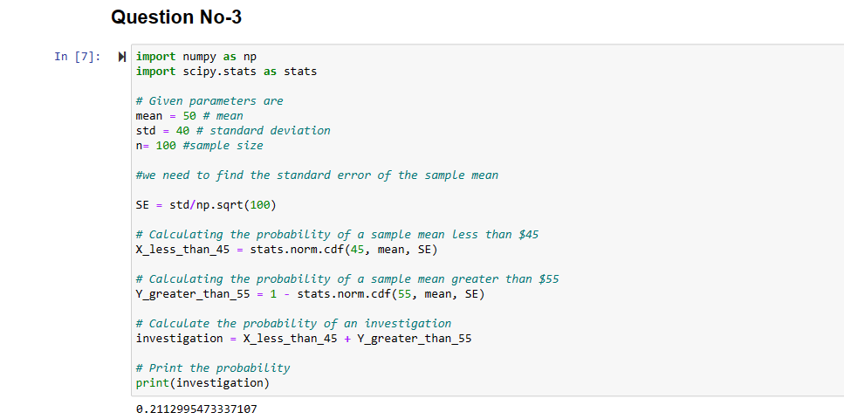

1. The auditors from the above example would like to maintain the probability of investigation to 5%. Which of the following represents the minimum number transactions that they should sample if they do not want to change the thresholds of 45 and 55? Assume that the sample statistics remain unchanged.
2. 144
3. 150
4. 196
5. 250
6. Not enough information

**Answer: D**

1. An educational startup that helps MBA aspirants write their essays is targeting individuals who have taken GMAT in 2012 and have expressed interest in applying to FT top 20 b-schools. There are 40000 such individuals with an average GMAT score of 720 and a standard deviation of 120. The scores are distributed between 650 and 790 with a very long and thin tail towards the higher end resulting in substantial skewness. Which of the following is likely to be true for randomly chosen samples of aspirants?
2. The standard deviation of the scores within any sample will be 120.
3. The standard deviation of the mean of across several samples will be 120.
4. The mean score in any sample will be 720.
5. The average of the mean across several samples will be 720.
6. The standard deviation of the mean across several samples will be 0.60

**Answer: D**

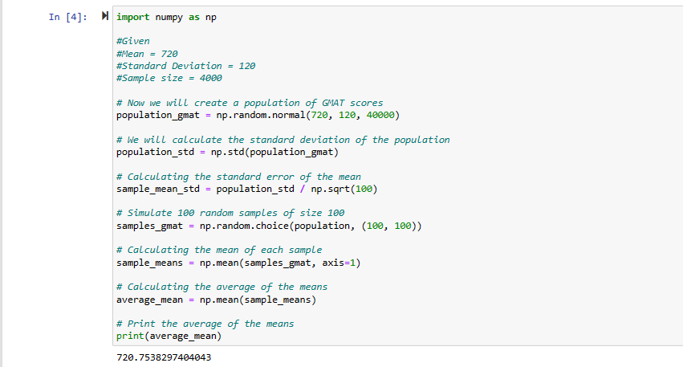

Since the GMAT scores are distributed normally, the central limit theorem suggests that the means of different samples will also be distributed normally. This means that the average of the means across several samples will be equal to the population mean, which is 720. Hence option D is correct and it is proven through above python code.